Class: S1 Weekly Planner Week 1 Topic: To explore how we can look after our bodies by Keeping Clean

Date: Monday 30th March – Friday 3rd April 2020
Learning Area | Activities
English with Media Education | Encourage children to use vocabulary within their experience / communication book to describe thoughts and feelings and use eye contact and body language to engage – model and encourage.  Individual work on letter formation, pencil control, pre writing and writing activities (spacing, orientation) relating to our topic – Keeping Clean Literacy Activities Sheets  Words of the week – hands soap shampoo hair teeth toothpaste  Match pictures to pictures /letters / words  Match letters to pictures /letters / words  Match words to pictures /letters / words  Reading activities- https://www.youtube.com/watch?v=ehhGLbTGwms  Spelling of our key words (1st 100 and 2nd 100 High Frequency words) /letter identification List 12 (as sent home)  Phonics – Onset and Rime in  SPAG – Identifying capital letters, full stops and question marks in print. Develop question marks in print and in own writing e.g. What is shampoo for?
Mathematics (including Financial Capability) | (as sent home)  Daily counting and focus on rote counting in 1s,5s and 10s.  Making sets practically and counting sets of 5, practically, pictorially and abstract activities within 15, 30  Subtracting 2 within 10,20,50,100  Numicon activities – identifying, recognising and matching Numicon patterns.  Maths Investigation  - Take a photo / look into the mirror and talk about your child’s height / length of hair /  - Look at photos of when your child was a baby and compare to how they look now using Maths Language i.e. taller / shorter / longer / bigger /smaller  - Discuss and use maths language to talk about similarities and differences  - Write a sentence e.g. When I was a baby, I had short hair. Now I am 12, I have longer hair etc.
Science & Tech  Environment & Society | To research and find out how to keep ourselves healthy through personal hygiene  - Reinforce the importance of using soap to wash our hands. Carry out this experiment at home.  https://www.bing.com/videos/search?q=soap+and+pepper+test+importance+of+using+soap&&view=detail&mid=4780B0E073DD11C8F4CF4780B0E073DD11C8F4CF&&FORM=VRDGAR&ru=%2Fvideos%2Fsearch%3Fq%3Dsoap%2520and%2520pepper%2520test%2520importance%2520of%2520using%2520soap%26qs%3Dn%26form%3DQBVDMH%26sp%3D-1%26pq%3Dsoap%2520and%2520pepper%2520test%2520importance%2520of%2520using%2520soap%26sc%3D0-45%26sk%3D%26cvid%3D1C21D0A9C3BA463289CCB0BB3679012B  Products we use to keep ourselves clean  Discuss the parts of the body that we clean (teeth, hair, private areas, etc.). Then, show images of Products we use to keep ourselves clean Resource 22  Ask a series of questions about what each product is used for. For example, ask: Which product would you use to shave your face? Allow them to use the icons on the sheet to help them answer.  Place a collection of personal hygiene items* (like those shown in Resource 22) in a shopping bag. Ask your child to take one item from the bag, and recite the following:  − I went to the chemist and I bought (product). I might use it like this (showing action), and I might use it (every day/week/month, etc.) You may need to demonstrate this to begin with  Extension Work  − Have your child take a product from the bag, place it on the table and say:  I went to the shop and I bought [their product and all the other products on the table]. Repeat until all of the items are out of the bag.  − Have your child mime using one of the products and you have to guess which product it is. You might want to separate into boy and girl groups for this game.  − Provide types of products in multiple brands and allow your child to play matching and sorting games with them. For ICT, children can insert images for each category.
The Arts | - Art – Printing with unused apples / potatoes / fruits / vegetables  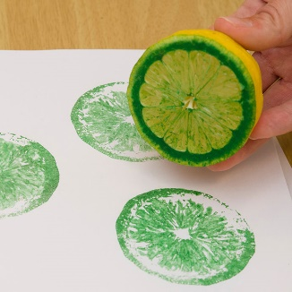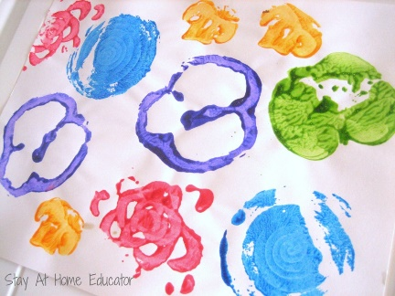  - Drama –Adopting the role of a customer / shopkeeper buying shampoo for hair etc.  - Music – To listen/remember/learn/join in with a range of songs  Music and movement songs S1 will be familiar with :  https://www.youtube.com/results?sp=mAEB&search_query=shake+your+sillies+out+  https://www.youtube.com/watch?v=3tx0rvuXIRg  https://www.youtube.com/watch?v=1gUbdNbu6ak  https://www.youtube.com/watch?v=k-2X98IsdNY  https://www.youtube.com/watch?v=oLaJ4jyKBUY  https://www.youtube.com/watch?v=0VLxWIHRD4E  - Human stages of development – Photograph Ed Sheeran’s Video
Physical Education | Daily Workout https://www.youtube.com/results?search_query=kids+workout  Daily relaxation – Yoga Session Cosmic Kids / or select another from this site https://www.youtube.com/watch?v=2cNjAj_o0SI&list=PL8snGkhBF7njuEl8V642ZeFwcbVRRPFLG
LLW  PD  Home Econ  Citizenship  Employability | PD – Exploring how to keep healthy  View and discuss https://www.healthforkids.co.uk/staying-healthy/the-way-to-go/  Play interactive games on https://www.healthforkids.co.uk/staying-healthy/  Home Economics –Making Healthy Food for our bodies – Fruit Salad  https://www.eatsamazing.co.uk/family-friendly-recipes/easy-recipes-for-kids/cooking-with-small-child-simple-fruit-salad  Song – Fruit Salad  https://www.bing.com/videos/search?q=fruit+salad+wiggles&view=detail&mid=567EA0CF35B4D4E2D852567EA0CF35B4D4E2D852&FORM=VIRE0&ru=%2fsearch%3fq%3dfruit%2bsalad%2bwiggles%26qs%3dn%26form%3dQBRE%26sp%3d-1%26pq%3dfruit%2bsalad%2bwiggles%26sc%3d2-19%26sk%3d%26cvid%3dA4F9BDE8E6AA40128C972E12455EED2C  Citizenship  Remember the most important learning for your child is to become as independent as possible. Please continue to practice self -help skills such as  - Dressing skills  - Putting on taking off coat (zips/buttons)  - Shoes (laces Velcro)  - Helping out with chores:  - Washing drying dishes, setting tables, putting away objects, sorting laundry etc.  - Personal Care: Become more independent brushing teeth, washing face, showering, shampooing, applying deodorant, styling their own hair etc.  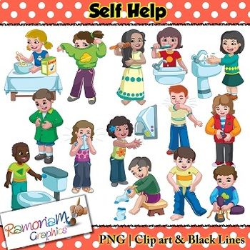
Religious Education | R.E session  Jairus’ Daughter Mark 5 :21-43  Worksheet https://www.sermons4kids.com/jairus_daughter_sp_colorpg.htm http://kidscorner.reframemedia.com/bible/stories/jairuss-daughter/ for Drama  Video https://www.youtube.com/watch?v=MGJ0TKRTEFI  Wordsearch https://www.sermons4kids.com/jairus_daughter_wordsearch.htm

