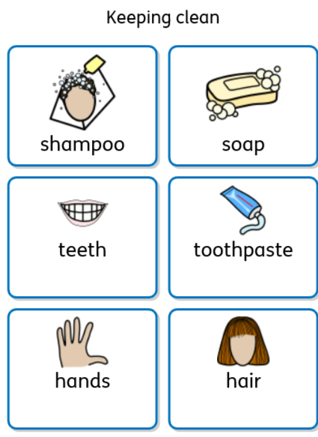

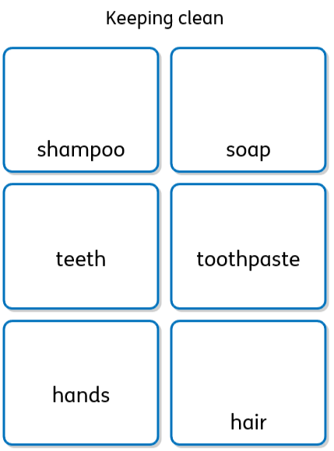

Missing Words

soap toothpaste shampoo

I use ……………………… for my hair.

I use …………………………… for my hands.

I use ……………………………………… for my teeth.

Write sentences using these words

wash hands soap clean healthy
teeth toothpaste hair shampoo

????????????????????????????????????????????????????????????????????????????? ?

Write questions using these words.
wash hands soap clean healthy
teeth toothpaste hair shampoo

- What is shampoo for?

- How do you keep clean?

- Where

